CasSama — Technical Architecture and Implementation Report
GreenGru · Sime Darby Property University Hackathon 2026
Scope: Implemented hackathon MVP, isolated OCPP demonstrations and proposed 2–4-bay field pilot
Evidence basis: Latest available repository snapshot (after booking-notification fix); project README and specialist documents; automated report; user-reported manual acceptance completion.
Prototype disclosure. The condominium sites, charger use, OCPP energy and month-ahead financial dashboards include simulated data. Booking-linked OCPP transactions generate calculated receipts, not independently confirmed collected payments. Resident votes are demonstration governance rules, not legal strata resolutions. No field commissioning, settlement integration or production security certification is claimed.

Executive summary
CasSama is a shared EV-charging management and planning prototype for residential townships. It addresses two connected inefficiencies: residential AC chargers may sit unused when residents are away, while drivers need accessible, compatible and cost-conscious charging options. A Joint Management Body (JMB) or Management Corporation (MC) can define limited visitor access to idle condominium bays without surrendering resident priority. Drivers can discover, compare and reserve eligible chargers; the system can link a reservation to a simulator-driven OCPP charging session and show calculated financial outcomes to the JMB.
A AI-powered conversational assistant supports charger recommendations, cost estimation, time-window suggestions, journey planning and booking proposals. It delegates factual calculations to deterministic application engines, uses a curated searchable knowledge base, and does not independently create bookings or charge payments. The same product also includes unit-linked resident credentials, a demonstrative sharing-policy vote, OCPP fault/recovery handling and a maintenance-cost-recovery model.
Hackathon acceptance position: isolated automated scenarios were reported passing and the owner has stated that all Phase 8 manual checks have been completed. These demonstrate prototype readiness for a controlled, simulated demo. Live equipment safety, contractual payments and statutory governance require separate validation.

1. Problem, objectives and boundaries

1.1 Problem
Residential EV chargers involve capital, maintenance and electrical-capacity commitments. Their utilisation varies over the day; reserving all bays exclusively for residents can waste usable capacity, but unconstrained public access risks leaving returning residents without charging. Drivers, meanwhile, must consider connector compatibility, battery level, charging duration, price, detour, reliability and availability. JMBs require clear auditability before consenting to shared use.

1.2 Technical objectives
- Surface public and residential charging options with comparable estimated prices, compatibility and charging usefulness.
- Allow visitor bookings only within JMB-approved sharing rules and protect designated resident capacity across the entire requested interval.
- Track a residential booking from confirmation through bay check-in and OCPP transaction completion, including fault handling.
- Separate forecast maintenance recovery from a ledger of booking-linked simulated, calculated charging receipts.
- Use AI to interpret charging requests and invoke bounded deterministic tools; require the driver to confirm any booking.
- Demonstrate resident credential verification and one-vote-per-verified-unit policy decisions without representing a demo vote as legal consent.

1.3 Out-of-scope for the implemented MVP
The system does not provide payment collection or verified bank settlement, independent residency verification, production-grade charger commissioning, multi-replica transactional persistence, legally binding JMB voting, verified vehicle state of charge, or a live physical charger pilot. Real site permitting, contractual CPO terms, grid assessments and privacy obligations remain future pilot dependencies.

2. Solution overview and stakeholders
Stakeholder | What CasSama provides | Critical boundary
EV driver / visitor | Map and Plan views, price comparison, reservation, charge progress | Booking success is checked by server; public prices/occupancy may be estimated
Resident | Home-condominium profile, resident-key booking, proposed-policy vote | A selected home condo is not proof of residence; a JMB-issued key is required
JMB / MC | Sharing hours, retained resident bays, maintenance, visitor manifest, recorded-revenue report, policy proposals | Demo PIN and JSON store are insufficient for real-world administration
Charge point operator (CPO) | Operational and financial scenario overview, charger connections | 70/30 allocation is illustrative, not a signed commercial agreement
Charging device / simulator | OCPP WebSocket interaction, meter readings and status events | Built-in simulator is not hardware metering or payment evidence
Two demonstration scenarios (proposal §1.5): (A) residential sharing and JMB maintenance-cost recovery; (B) AI-assisted trip/charging planning.

3. System architecture
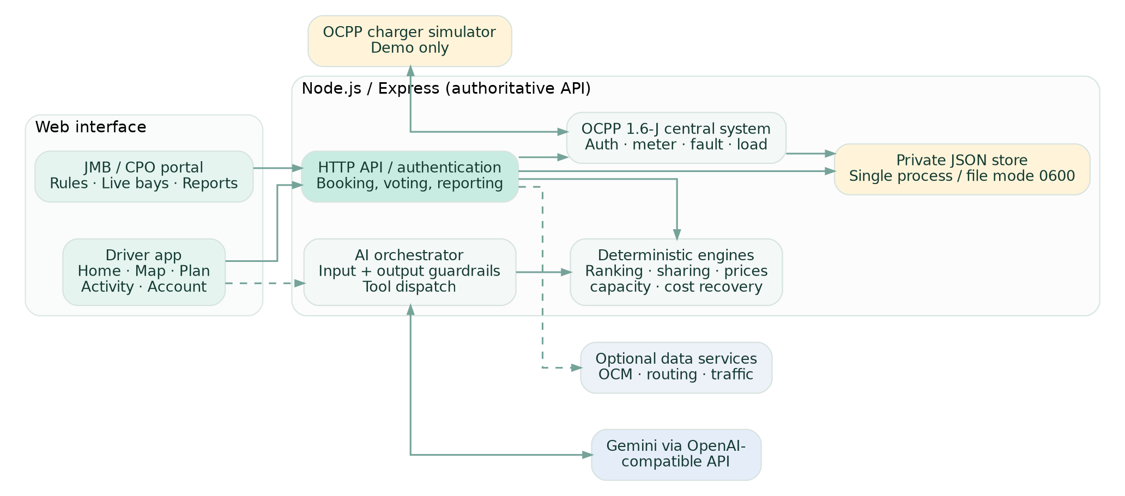
Figure 1. Logical architecture reconstructed from application modules; dashed lines denote optional/provider interactions, not guaranteed always-on services.

3.1 Frontend
The application is a vanilla JavaScript single-page-style website built from index.html, app.js, state.js, views/* and styles.css. The driver navigation includes Home, Map, Plan, Activity and Account; JMB/CPO use jmb.html and JMB view modules. The frontend can render deterministic Plan/Map recommendations and AI chat results, and can initiate booking, check-in, demo charging and JMB workflows through data/api.js.
Client-side battery display is an estimate: on public charging demos a local simulation animates progress; on booking-linked residential demo sessions, Activity derives progress from interim OCPP simulator MeterValues returned by the charging-status API. Neither is a vehicle battery-management-system measurement.

3.2 Backend and state
server/index.js boots a Node.js 20+ Express service (normally http://localhost:4300). server/app.js serves frontend assets and HTTP APIs. Authoritative booking and authentication decisions occur on the server; frontend predictions or AI suggestions are provisional. Shared configuration and pricing/forecast/booking engines reside in engine/*, with charger, condominium, tariff and knowledge data under data/*.
server/store.js persists bookings, resident-key metadata, policy proposals, charging sessions, maintenance and other state in a local JSON store. Files are written via private temporary-file replacement and mode 0600. This is suitable for single-process demo state, not for concurrent production server instances.

3.3 External dependencies
External system | Function | Handling when unavailable
LLM API (OpenAI-compatible endpoint) | Natural-language orchestration and tool selection | Deterministic trip parser and Map/Plan recommendations remain available
Open Charge Map | Public charger data when configured | Cached data or built-in demonstration charger list
OSRM / Photon | Road-routing and place search | Built-in locations, estimates and reduced route functionality
TomTom (optional) | Traffic and station data with configured server key | Routes and recommendations retain non-live estimates
OCPP 1.6-J WebSocket | Charger telemetry and transaction lifecycle | Built-in simulator for controlled demos; no live hardware claim
The actual availability, tariff and accuracy of third-party data depend on the provider and freshness of its records. A recommended charger is not a guaranteed free physical bay.

4. AI agent architecture and guardrails
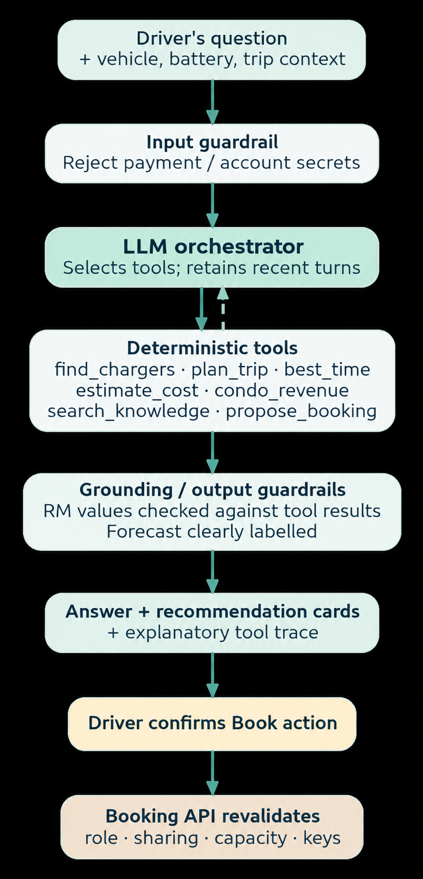
Figure 2. Conversational tool-calling workflow and server-side booking confirmation boundary.

4.1 Design choice
The language model is an orchestrator, not the pricing or capacity authority. server/agent.js runs an OpenAI-compatible chat-completion loop with a limited recent-turn history (last six messages), at most four tool rounds and eight tool calls per round. engine/agent.js defines function schemas, deterministic tool implementations, prompts, input validation and output grounding. The repository defaults to Qwen/DashScope settings, while environment variables allow switching to a compatible provider. Gemini gemini-2.5-flash (Change to appropriate model) was exercised successfully by the user in Phase 7.

4.2 Specialised tools
Tool | Implementation role | Source
find_chargers | Rank compatible chargers by battery-sensitive preferences, costs, detour and reliability | engine/score.js
plan_trip | Plan longer journeys with estimated fast-charging stops and energy constraints | engine/trip.js
best_time | Compare estimated hourly costs/occupancy over the next 24 hours | engine/schedule.js
estimate_cost | Multiply validated kWh by the relevant charger tariff | engine/pricing.js
condo_revenue | Simulate monthly utilisation, forecast receipts, cost recovery and idle hours | engine/economics.js, engine/recovery.js
search_knowledge | Retrieve curated facts about CasSama rules and tariff assumptions | engine/kb.js, data/knowledge.js
propose_booking | Perform preliminary residential eligibility screening and produce a confirmation action | engine/reservations.js
fill_trip_form | Reflect stated vehicle, battery, destination and parking preferences into Plan | engine/agent.js

4.3 Knowledge retrieval, not model training
data/knowledge.js provides an authored domain knowledge collection about scoring, resident sharing, tariffs, privacy, voting, OCPP and revenue. engine/kb.js searches it via lexical/BM25-style retrieval. This is a lightweight retrieval-augmented response mechanism, not a vector database, web-browsing agent or fine-tuned model. Knowledge passages are referenced in the agent response when retrieved.

4.4 Input and output controls
The input guardrail refuses payment-card numbers, account credentials and similar unsafe requests before they reach the provider. Numeric energy arguments are validated (positive and at most 200 kWh in cost/schedule tools); unknown charger IDs or unsupported destinations return explicit errors. The money guardrail cross-checks each stated RM amount against tool-result evidence and may request one answer correction or remove an ungrounded claim. Outputs derived from condo_revenue are labelled as simulated forecasts.
For bookings, propose_booking is informational only. The driver must actively confirm, and POST /api/bookings re-evaluates eligibility against current booking records, credentials, faults and sharing rules. Some provider content or estimates may still be imperfect; the guardrail is a constraint, not a proof of all factual correctness.

4.5 Key configuration (CHANGE TO APPROPRIATE MODEL)
export AI_BASE_URL="https://generativelanguage.googleapis.com/v1beta/openai"
export AI_MODELS="gemini-2.5-flash"
export AI_TIMEOUT_MS=60000
# Export AI_API_KEY securely in the local shell; do not place it in source files.
npm start
GET /api/config reports whether an AI key is configured; ai: true does not on its own establish that the provider call succeeds. A live test prompt is required. Previously exposed credentials must be revoked and replaced.

5. Smart charging recommendation and scheduling

5.1 Eligibility filtering
The ranking process in engine/score.js first excludes options that cannot reasonably serve the requested trip: incompatible connectors, low reliability, out-of-range sites, violations of fast-only and maximum-price preferences, inaccessible visitor sharing, and bays that cannot provide useful energy within the intended parking duration. The FAULTY reliability threshold is 0.6. The driver battery determines an estimated travel range using battery size, vehicle efficiency and a 10% range buffer.

5.2 Battery-sensitive ranking
The remaining options are scored using normalised charging cost, overall additional time and unreliability, with an adjustment for a preferred operator. Weights vary with initial state of charge:
Mode | Battery | Cost weight | Time weight | Risk weight
Urgent | 15% or less | 0.10 | 0.60 | 0.30
Balanced | Above 15%, up to 50% | 0.40 | 0.40 | 0.20
Saver | Above 50% | 0.60 | 0.25 | 0.15
An additional engine/balance.js routine adjusts recommendations to reduce crowding at constrained DC chargers. These scores are heuristic product rules, not a statistically validated demand-prediction model.
The displayed estimated cost for delivered energy is price_per_kWh × energy_delivered_kWh; an individual charger may deliver less than the full requested amount when parking time is short. Charger power is capped by the lower of the charger rating and the vehicle’s applicable AC/DC capability.

5.3 Cheapest-time and journey planning
engine/schedule.js evaluates prospective hour-level prices and simulated occupancy, selecting a low-cost window and avoiding relatively crowded hours as a tie-breaker. It does not currently verify a complete multi-hour booking interval from the scheduling forecast. Availability must be rechecked using the booking API.
Longer trips use engine/trip.js and supported destination/highway charger data to estimate energy need and stops, generally charging only what is necessary for the next leg and observing an 80% DC-charge ceiling. Highway sites may be demo records, and provider routing may refine distance estimates. Journey outputs are planning aids, not roadworthiness or range guarantees.

6. Reservations and resident-first capacity

6.1 Sharing governance
Each condo maintains JMB-controlled settings (engine/sharing.js): enabled/paused, applicable days, fixed visitor hours or automatic sharing, number of reserved resident bays, and a visitor tariff. Auto mode only considers sharing from 07:00–22:00 and includes a forecasted resident-demand buffer of 10%, plus the explicit retained resident bays.

6.2 Authoritative capacity check
engine/reservations.js uses half-open intervals: two bookings overlap when A.start < B.end and B.start < A.end. For a proposed booking, it examines overlapping bookings and relevant time boundaries, including minute-by-minute points for changing sharing rules. It reduces capacity for faulty bays, rejects full sites, and applies a distinct visitor ceiling that protects capacity for residents. Legacy bookings without a role are treated as visitors.
This is aggregate site capacity, not a guaranteed physical bay assignment. A specific connected, available, non-faulty bay is selected during check-in. If a request is rejected, findAlternativeSlots proposes up to three alternatives, stepping 30 minutes over a 72-hour horizon.

6.3 Credentials and cancellation
Residents must present a JMB-issued, condo-specific key. The backend stores only its SHA-256 hash and revocation/expiry metadata. Keys expire after 30 days unless revoked earlier; verified-unit keys additionally support governance. Bookings return a unique booking ID and cancellation token. The cancellation token is checked server-side; successful cancellation releases held capacity. Charging cannot be erased by cancelling after charging starts or completes.

6.4 Check-in lifecycle
A residential booking’s owner submits booking ID, cancellation token and bay during the actual server-time reservation interval. The backend confirms site membership, charger connection/status, fault state, bay non-occupancy and absence of a previous check-in before issuing a one-time OCPP tag. Neither the simulated app clock nor the AI assistant can bypass these checks.

7. OCPP integration and demo charging

7.1 Charger connection and telemetry
server/ocpp.js implements a prototype OCPP 1.6-J central system over authenticated WebSocket connections at /ocpp/<condo>-<bay>, using the ocpp1.6 subprotocol and HTTP Basic authentication. It handles boot, heartbeat, availability, fault/status, authorisation, start/stop transactions and meter values. A charger entering a fault state is logged in JMB maintenance and removed from service until a repair/available event.
SetChargingProfile limits current allocation across active bays using a configured site limit; the demo default assumes 60% of nameplate load until a professional site electrical assessment supplies a safe limit. This setting is a software constraint, not proof of safe wiring or grid compliance.

7.2 Booking-linked charging sequence
- A valid resident/visitor booking is confirmed by the server.
- The booking owner checks into an available bay and receives a one-time OCPP idTag.
- A matching Authorize/StartTransaction is received and bound to the same booking and bay.
- Interim MeterValues update the driver’s simulated live kWh and battery-estimate display.
- A matching StopTransaction with a plausible cumulative meter value computes the final delivered kWh and calculated charging receipt.
- The authenticated JMB monthly report includes the completed session. Interrupted, corrupt or unreconciled transactions are flagged for review and excluded from normal booked-session revenue.

7.3 Controlled hackathon simulation
With DEMO_OCPP_CONTROLS=1, the backend exposes booking-owner-only, tag-verified POST /api/bookings/:id/demo-ocpp actions for start and finish. These call an owned simulator connection to produce protocol messages and sample meter progress. Demo controls are disabled by default and are not intended for physical deployment. The animated battery percentage is an estimate derived from a selected starting level and simulator energy—not a reading from a real vehicle.
An unlinked simulator transaction is not a booking-linked receipt. Simulator sessions may show protocol realism, but no EV received verified electricity and no customer payment was collected.

8. Financial model and reporting

8.1 Two financial evidence classes
Display/data source | Meaning | Not evidence of
JMB historical/forecast dashboards, simulateCondoMonth() | Illustrative utilisation, receipts and six-month trend projection | Metered kWh, paid customer invoices, true monthly profit
JMB recorded-charging API (chargingRevenueReport()) | Calculated receipts from validated completed booking-linked OCPP transactions | Bank settlement, verified hardware measurements when simulator is used

8.2 Maintenance-cost-recovery formula
For an illustrative monthly period:
operating_surplus = revenue − electricity_cost − other_variable_cost − fixed_monthly_cost − maintenance_cost
JMB_allocation = max(operating_surplus, 0) × JMB_share
CPO_allocation = max(operating_surplus, 0) − JMB_allocation
per_unit_saving = JMB_allocation / number_of_units
The code uses configurable condo allocations, with a typical 30% JMB / 70% CPO split in its demo. Allocation only occurs for a positive operating surplus. Its break-even calculation uses effective per-kWh contribution margin and monthly costs.

8.3 Proposal-aligned illustrative base case
Assumption or computed outcome | Value
Monthly delivered energy | 4,050 kWh
Average receipt rate | RM0.90/kWh
Gross receipts | RM3,645.00
Electricity cost (RM0.55/kWh) | RM2,227.50
Other variable costs (RM0.05/kWh) | RM202.50
Fixed monthly cost (four bays × RM125) | RM500.00
Operating surplus before additional repairs | RM715.00
JMB illustrative share (30%) | RM214.50
These assumptions come from the proposal’s §6.2 example and match config.js/engine/recovery.js. They are not actual site earnings; real tariffs, utilisation, maintenance, taxes, insurance and CPO contracts may materially change the result.

8.4 Isolated four-bay simulator evidence
The Phase 8 automated pilot reported 22.5 kWh, RM22.75 calculated receipts, and operating surplus of approximately −RM490.76 after including the illustrative RM500 fixed monthly cost; hence RM0 JMB allocation in that small test sample. These numbers are test-fixture outcomes, not six-month operating performance, and must never be combined with the 4,050-kWh monthly forecast as if they represent the same interval.

9. Access control, privacy and governance

9.1 JMB authentication and private data
server/auth.js signs condo-scoped bearer tokens with HMAC-SHA256, expiring after 12 hours. Wrong PIN attempts are throttled (up to 10 failures in a 10-minute window per condo/client). Sensitive JMB routes require an authenticated token for the specific condominium. The server keeps the JMB secret, OCPP password and AI credentials in environment variables; test PINs are demonstration credentials, not production secrets.
A public world/charger response does not expose resident access secrets, booking cancellation tokens or JMB bearer tokens. Visitors’ plates are intended for privileged expected-visitor workflows. The single-process private JSON store and browser-side access controls do not constitute full production privacy governance.

9.2 Verified-unit voting
A JMB may issue a resident access key after checking a unit identifier. The system HMAC-hashes a normalised unit reference and tracks one vote per verified unit, even if the JMB issued several credentials for that unit. Booking-only keys cannot vote. Proposals close after seven days; the demonstrative acceptance rule is a simple majority with at least 10% of condominium units voting. Sample votes are non-binding previews, and old unverified device-ID votes are not accepted as verified consent.
These are software demonstration thresholds. Actual resident rights, quorum, proxy voting, statutory requirements and management authority need confirmation with the applicable strata legislation, by-laws and qualified counsel.

9.3 Security limitations
Before deployment, the prototype needs verified ownership/tenancy enrolment, hardened administrator login and rotation procedures, secret management and incident logging, transactional storage, per-tenant access audits, data minimisation/retention review, payment-security architecture and independent threat testing. An exposed Google API key from development should be revoked and replaced before publication; no secret value is reproduced in this document.

10. HTTP API reference (selected)
Method and path | Purpose | Access and notable behaviour
GET /api/health | Health indication | Public
GET /api/config | Feature flags (ai, traffic, optional demo OCPP) | Public; flag is not proof that AI calls succeed
GET /api/world | Shared state needed for driver recommendations | Public, privacy-filtered
POST /api/agent | Conversational AI orchestration | Rate-limited; requires configured provider
POST /api/bookings | Create residential/shared booking | Server validates role, timing, resident key, capacity; failure often 409
DELETE /api/bookings/:id | Cancel owned booking | Requires matching cancelToken; cannot cancel after charging starts
POST /api/bookings/:id/check-in | Assign a connected bay to booking | Requires booking token; actual booked interval; returns one-time tag
POST /api/bookings/:id/charging-status | Retrieve owner-visible OCPP charging state | Requires booking token; returns interim simulated meter when available
POST /api/bookings/:id/demo-ocpp | Start/finish owned demo simulation | Only when DEMO_OCPP_CONTROLS=1; token + one-time tag required
POST /api/jmb/login | Obtain a condominium-scoped JMB token | PIN authentication and throttling
GET /api/jmb/:condoId | JMB operational/visitor view | Condo-scoped bearer token
GET /api/jmb/:condoId/charging-revenue?month=YYYY-MM | Month’s completed linked sessions and cost recovery | Condo-scoped bearer token; not payment reconciliation
POST /api/jmb/:condoId/resident-keys | Issue resident or verified-unit key | JMB token; secret shown only at issue time
POST /api/condos/:condoId/proposal/vote | Cast verified-unit vote | Valid unit-linked resident credential required
POST /api/jmb/:condoId/maintenance | Record maintenance events | JMB token
GET /api/ocpp/:condoId | View OCPP status summary | Operational snapshot; not a settlement ledger
See server/app.js for exact request schemas. This table is an implementation overview, not an externally versioned public API contract.

11. Quality assurance and acceptance evidence

11.1 Automated verification
The codebase includes Node’s native test-runner suite plus an isolated acceptance script (npm run acceptance:verify). The earlier Phase 8 report recorded 259/259 regression tests passing, five acceptance scenarios passing, and a four-bay OCPP pilot. Later development introduced demo-meter and notice fixes with additional targeted tests; the number reported above is a historical test-run count, not a fresh test execution on the owner’s final Git branch.
Core automated scenarios cover protected resident capacity, overlapping booking rejection, cancellation ownership, unit-verified voting, AI tool-calling with a mock model, booking-linked OCPP transactions, fault handling, revenue exclusions, and four-bay pilot capacity. The user subsequently reported successful end-to-end browser checks for M1–M10, including live Gemini conversation, resident priority, OCPP simulation, JMB reporting, maintenance fault/recovery and invalid booking/security controls. This distinction between automated evidence and user-reported manual acceptance is intentional.

11.2 Local reproduction
npm ci
npm run acceptance:verify
npm run pilot:verify
npm test
# Controlled local demo; never enable this against physical chargers.
DEMO_OCPP_CONTROLS=1 npm start
For reliable demonstrations, use a fresh disposable booking, correct real server time, a connected simulator bay and fictional names/plates. Ensure the local jirui branch is tested separately, since this document was authored from the last available repository snapshot.

11.3 Traceability to proposal
Proposal focus | Prototype evidence | Outstanding real-pilot work
§1.4 discovery/booking | Map/Plan, public chargers, resident/visitor rules, overlap checks | Operator integration, physical bay enforcement
§1.4.2 JMB operational tools | Live OCPP state, faults, maintenance, cost-recovery dashboards | Operational SLAs, commercial reconciliation
§1.4.3 AI smart planning | Gemini tool calling, ranking, schedules, trips, KB, guarded booking proposal | Long-horizon evaluation, fresh data feeds
§1.5 two showcase scenarios | End-to-end visitor + charging demo; AI planning conversation | Live-site case study
§6 pilot feasibility | Isolated four-AC-bay OCPP simulation and test | One contracted CPO, 2–4 AC chargers, permissions, site survey
§6.2 economics | RM0.55/RM0.05/RM500 costs, positive-surplus allocation | Verified tariffs, actual utilisation, invoices and settlements
§7.2 security/operational risk | JMB tokens, resident-key hashes, booking ownership, review queue | Independent security, privacy and electrical compliance review

12. Limitations, risks and realistic next steps
Risk / limitation | Why it matters | Mitigation or next step
OCPP simulator ≠ installed charger | Synthetic energy is not verified delivered power | Deploy a compatible charger under supervised pilot conditions
Forecast ≠ collected revenue | Projected financial benefit may be misleading | Label forecast and calculated receipts distinctly; integrate payment settlement later
Aggregate booking capacity | A valid slot does not guarantee a particular bay until check-in | Add physical bay allocation and site operation policy
Single-process JSON persistence | Concurrent replicas can race or lose consistency | Move to transactional database and event audit trail
JMB-issued unit identity | Manual verification may be inconsistent or compromised | Formal enrolment, audit and revocation processes
Model or data provider outages | Demo calls can time out or return stale/partial data | Retain deterministic Map/Plan fallback; cache public data appropriately
Privacy and security | Plates, keys, API tokens and logs create operational risk | Rotate exposed credentials; least privilege, retention and security assessment
Electric load assumptions | Default 60% cap is not an engineering study | Licensed electrical assessment, metering and hardware commissioning
Governance thresholds | Demo rule may not satisfy applicable strata law | Agree voting and approval workflow with legal and management stakeholders

Appendix A — Implementation map
Concern | Main source files
Frontend entry and navigation | index.html, app.js, views/driver.js, views/jmb.js, styles.css
Remote API and local fallback | data/api.js, state.js
AI orchestration | server/agent.js, engine/agent.js, engine/kb.js, data/knowledge.js
Charger recommendation and trip | engine/score.js, engine/balance.js, engine/trip.js, engine/schedule.js
Sharing and booking | engine/sharing.js, engine/reservations.js, server/app.js
Charging and metering | server/ocpp.js, server/ocpp-sim.js, engine/charging.js, engine/demo-meter.js
Financials | engine/economics.js, engine/recovery.js, engine/pricing.js, views/jmb-recorded.js
Access and governance | server/auth.js, engine/governance.js, views/governance.js
Tests | test/acceptance.test.js, test/pilot-readiness.test.js, test/charging-lifecycle.test.js
Original supplementary docs | AI_AGENT_REVIEW.md, PHASE8_ACCEPTANCE.md, PILOT_READINESS.md, GOVERNANCE_VERIFICATION.md, SECURITY_AUDIT.md, docs/CHARGING_LIFECYCLE.md

Appendix B — Evidence classification
- Implemented code: directly inspected in the repository snapshot.
- Automated result: previously reported in Phase 8 output; not silently reclassified as a new test execution.
- Manual result: user-reported browser acceptance, not independently witnessed by this report.
- Illustrative scenario: assumed or simulated, not real-world metering, contracted revenue or financial settlement.
- Pilot recommendation: future deployment requirement, not an implemented feature.

